Project Planning Phase
Project Planning Template (Product Backlog, Sprint Planning, Stories, Story Points)

Date | 15 February 2025
Team ID | Team-BMS-2025
Project Name | Bookstore Management System (MERN Stack)
Maximum Marks | 5 Marks

Product Backlog, Sprint Schedule, and Estimation (4 Marks)
The Bookstore Management System backlog is organized into 4 sprints of 18 user stories, estimated in Fibonacci-scale story points (1, 2, 3, 5, 8) based on Very Easy / Normal / Moderate / Difficult effort.
Sprint | Functional Requirement (Epic) | User Story # | User Story / Task | Story Points | Priority | Team Members
Sprint-1 | Registration | USN-1 | As a user, I can register for the application by entering my name, email, mobile number, and password. | 3 | High | Frontend Developer
Sprint-1 | Registration | USN-2 | As a user, I will receive a confirmation email once I have registered for the application. | 2 | High | Backend Developer
Sprint-1 | Registration | USN-3 | As a user, I can register for the application through Gmail. | 3 | Medium | Backend Developer
Sprint-1 | Login | USN-5 | As a user, I can log into the application by entering my email and password. | 2 | High | Backend Developer
Sprint-1 | Book Discovery | USN-6 | As a user, I can search and filter books by title, author, genre, or category. | 5 | High | Full-Stack Developer
Sprint-2 | Registration | USN-4 | As a user, I can register for the application through LinkedIn. | 2 | Low | Backend Developer
Sprint-2 | Cart & Checkout | USN-7 | As a user, I can add books to my cart and view the auto-calculated total. | 3 | High | Frontend Developer
Sprint-2 | Cart & Checkout | USN-8 | As a user, I can check out and pay using UPI, card, or cash on delivery. | 8 | High | Full-Stack Developer
Sprint-2 | Order Tracking | USN-9 | As a user, I can view my order history and track the current delivery status. | 5 | High | Full-Stack Developer
Sprint-2 | Organizer Inventory | USN-12 | As an organizer, I can add a new book with price, stock, and description. | 3 | High | Backend Developer
Sprint-3 | Reviews | USN-10 | As a user, I can rate and review a book after it has been delivered. | 3 | Medium | Frontend Developer
Sprint-3 | Organizer Dashboard | USN-11 | As an organizer, I can log in to a dedicated dashboard to manage my listings. | 5 | High | Full-Stack Developer
Sprint-3 | Organizer Inventory | USN-13 | As an organizer, I can update pricing and stock levels for existing books. | 3 | Medium | Backend Developer
Sprint-3 | Order Processing | USN-14 | As an organizer, I can update the delivery status of orders containing my books. | 5 | High | Backend Developer
Sprint-3 | Organizer Approval | USN-15 | As an admin, I can review and approve or reject new organizer registrations. | 3 | High | Backend Developer
Sprint-4 | User Management | USN-16 | As an admin, I can view, suspend, or delete user and organizer accounts. | 3 | Medium | Backend Developer
Sprint-4 | Review Moderation | USN-17 | As an admin, I can moderate or remove reported reviews. | 3 | Medium | Backend Developer
Sprint-4 | Order Support | USN-18 | As a customer care executive, I can look up any customer's order to help resolve delivery issues. | 3 | Low | QA Engineer

Project Tracker, Velocity & Burndown Chart (4 Marks)
Sprint | Total Story Points | Duration | Sprint Start Date | Sprint End Date (Planned) | Story Points Completed (as on Planned End Date) | Sprint Release Date (Actual)
Sprint-1 | 15 | 6 Days | 17 Feb 2025 | 22 Feb 2025 | 15 | 22 Feb 2025
Sprint-2 | 21 | 6 Days | 24 Feb 2025 | 01 Mar 2025
Sprint-3 | 19 | 6 Days | 03 Mar 2025 | 08 Mar 2025
Sprint-4 | 9 | 6 Days | 10 Mar 2025 | 15 Mar 2025

Velocity
Velocity = Total Story Points Completed / Number of Sprints
Planned backlog total = 15 + 21 + 19 + 9 = 64 story points across 4 sprints
Velocity = 64 / 4 = 16 Story Points per Sprint (team's planned average velocity)
After Sprint-1 (actual): Velocity so far = 15 completed / 1 sprint = 15 Story Points per Sprint

Average Velocity per Day
Using the team's planned velocity of 16 story points per 6-day sprint:
AV (story points/day) = Velocity / Sprint Duration = 16 / 6 ≈ 2.67 story points completed per day

Burndown Chart
A burndown chart is a graphical representation of work remaining versus time. Below is the Sprint-1 burndown for the Bookstore Management System, plotting the ideal linear burn-down of 15 story points over 6 days against the team's actual progress.
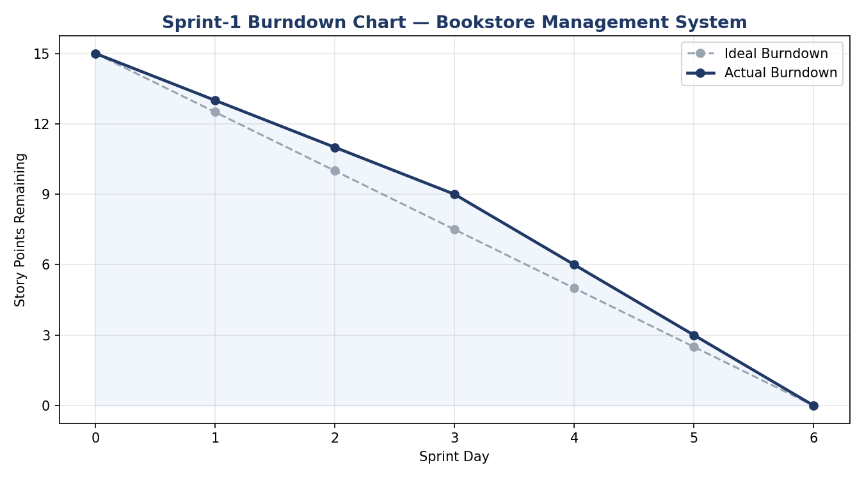

Reference: https://www.visual-paradigm.com/scrum/scrum-burndown-chart/ | https://www.atlassian.com/agile/tutorials/burndown-charts

